**IS - ASSIGNMENT - 1**

**HASSAN ALI**

**K20-1052**

**BSE-7B**

**Encryption and Decryption of .txt and .exe file using DES and AES**

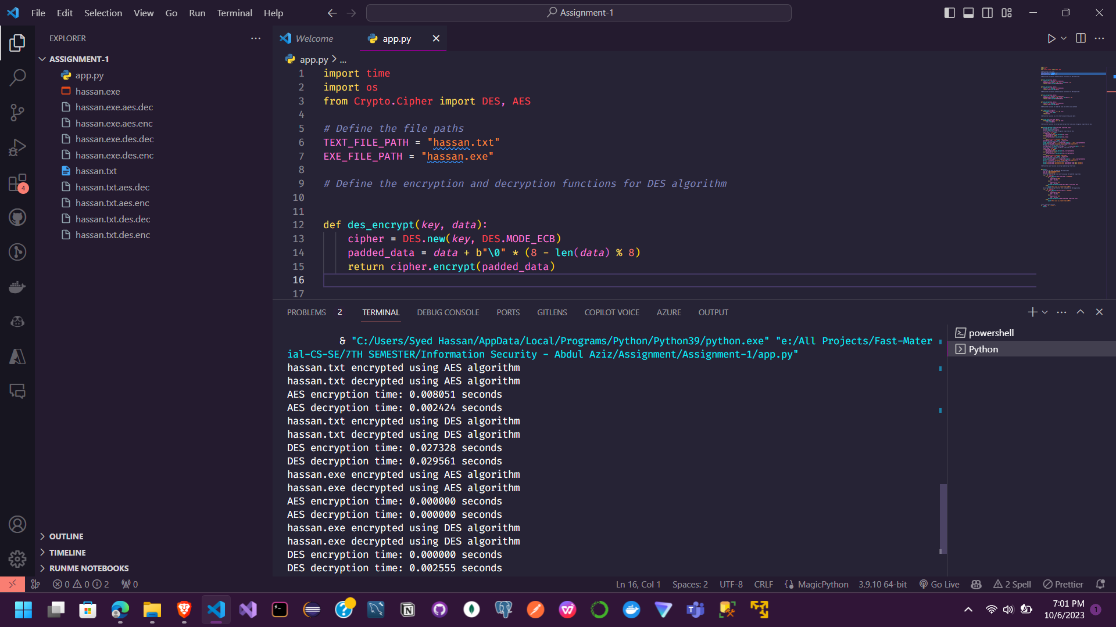

import time

import os

from Crypto.Cipher import DES, AES

*# Define the file paths*

TEXT_FILE_PATH = "hassan.txt"

EXE_FILE_PATH = "hassan.exe"

*# Define the encryption and decryption functions for DES algorithm*

def des_encrypt(*key*, *data*):

    cipher = DES.new(*key*, DES.MODE_ECB)

    padded_data = *data* + b"\0" * (8 - len(*data*) % 8)

    return cipher.encrypt(padded_data)

def des_decrypt(*key*, *data*):

    cipher = DES.new(*key*, DES.MODE_ECB)

    return cipher.decrypt(*data*)

*# Define the encryption and decryption functions for AES algorithm*

def aes_encrypt(*key*, *data*):

    cipher = AES.new(*key*, AES.MODE_ECB)

    padded_data = *data* + b"\0" * (16 - len(*data*) % 16)

    return cipher.encrypt(padded_data)

def aes_decrypt(*key*, *data*):

    cipher = AES.new(*key*, AES.MODE_ECB)

    return cipher.decrypt(*data*)

*# Define the function to read the file and return its contents*

def read_file(*file_path*):

    with open(*file_path*, "rb") as file:

        data = file.read()

    return data

*# Define the function to write the file with the given data*

def write_file(*file_path*, *data*):

    with open(*file_path*, "wb") as file:

        file.write(*data*)

*# Define the function to encrypt and decrypt the file using the given algorithm and key*

def encrypt_decrypt_file(*file_path*, *algorithm*, *key*):

*# Read the file contents*

    data = read_file(*file_path*)

*# Encrypt the data using the given algorithm and key*

    start_time = time.time()

    if *algorithm* == "DES":

        encrypted_data = des_encrypt(*key*, data)

    elif *algorithm* == "AES":

        encrypted_data = aes_encrypt(*key*, data)

    else:

        raise ValueError("Invalid algorithm")

    encryption_time = time.time() - start_time

*# Write the encrypted data to the file*

    write_file(*file_path* + "." + *algorithm*.lower() + ".enc", encrypted_data)

    print(f"{*file_path*} encrypted using {*algorithm*} algorithm")

*# Read the encrypted data from the file*

    encrypted_data = read_file(*file_path* + "." + *algorithm*.lower() + ".enc")

*# Decrypt the data using the given algorithm and key*

    start_time = time.time()

    if *algorithm* == "DES":

        decrypted_data = des_decrypt(*key*, encrypted_data)

    elif *algorithm* == "AES":

        decrypted_data = aes_decrypt(*key*, encrypted_data)

    else:

        raise ValueError("Invalid algorithm")

    decryption_time = time.time() - start_time

*# Write the decrypted data to the file*

    write_file(*file_path* + "." + *algorithm*.lower() + ".dec", decrypted_data)

    print(f"{*file_path*} decrypted using {*algorithm*} algorithm")

*# Print the encryption and decryption times*

    print(f"{*algorithm*} encryption time: {encryption_time:.6f} seconds")

    print(f"{*algorithm*} decryption time: {decryption_time:.6f} seconds")

*# Define the main function to encrypt and decrypt the files*

def main():

*# Define the keys for AES and DES algorithms*

    aes_key = b"1234567890123456"

    des_key = b"abcdefgh"

*# Encrypt and decrypt the text file using AES and DES algorithms*

    for i in range(2):

        if os.path.getsize(TEXT_FILE_PATH) < 10000000:

            if i == 0:

                algorithm = "AES"

                key = aes_key

            else:

                algorithm = "DES"

                key = des_key

            encrypt_decrypt_file(TEXT_FILE_PATH, algorithm, key)

        else:

            print("File size is greater than 10MB")

*# Encrypt and decrypt the exe file using AES and DES algorithms*

    for i in range(2):

        if os.path.getsize(EXE_FILE_PATH) < 10000000:

            if i == 0:

                algorithm = "AES"

                key = aes_key

            else:

                algorithm = "DES"

                key = des_key

            encrypt_decrypt_file(EXE_FILE_PATH, algorithm, key)

        else:

            print("File size is greater than 10MB")

*# Call the main function*

if __name__ == "__main__":

    main()